**LockedMe.com – Virtual Key Repositories**

**Description**

An application that helps users to add, delete, and search file in the directory and also helps in displaying file in ascending order. Developed by Varun Sharma.

**GitHub Link**

https://github.com/varun1699sharma/LockedMe

**Core Concepts**

File Handling, Exceptional Handling, Recursion, Sorting, Searching, Git and many more.

**Features of the application**

* Displaying file names in an ascending order.
* Option to add a file to the application.
* Option to delete a file from the application.
* Option to search a file from the application.
* Navigation option
* Option to close the application.

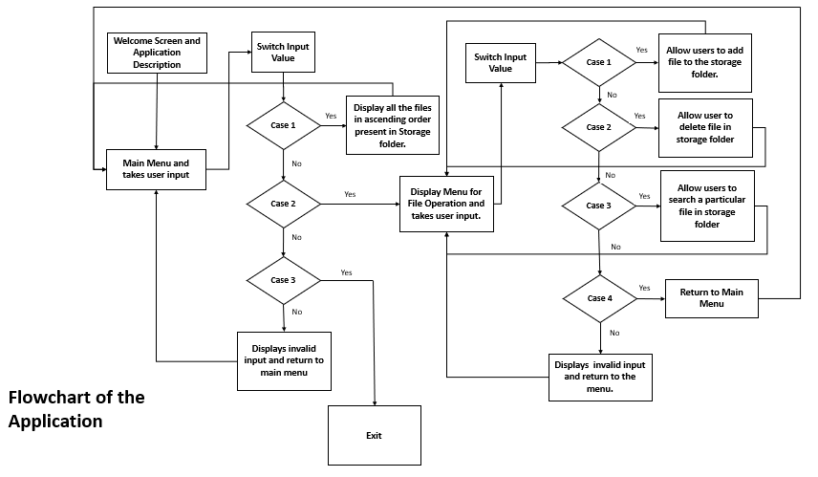

It consists of 3 java files.

* **App.java :** This is the main java file that runs the application. It is used for displaying the main menu of the application and it connects other two java files.
* **Ascending.java :** This java file is used for displaying the files in ascending order present in the storage folder.
* **Operations.java :** This java file is used for performing various file handing operations like adding a file , deleting a file, and searching for a file in the storage folder.